Lesson plan
Unit of a long term plan: Equations, inequalities, and systems of inequalities in two variables , 11-12th lessons |  | School:  Kyzylorda Bilim-Innovation Lyceum  for girls №10
Date: |  | Teacher: Zhanerke Sabyr
Class: 9 A |  | Number present: | Absent:
Lesson title |  | Nonlinear equations: quadratic equations and its graph
Learning objectives(s) that this lesson is contributing to (link to the Subject program) |  | 9.4.2.1 solve quadratic equations;
Lesson objectives |  | All learners will be able to:  Identify non-linear equation.  Most learners will be able to:  Solve quadratic equations and draw its graph.  Some learners will be able to:  Solve real life based problems.
Assessment criteria |  | - Convert verbal phrases into algebraic equations.  - Apply the special formulas and parabola to solve problems
Language objectives |  | Key words: non-linear, parabola, vertex, critical point.  Key questions:  -How can we draw the parabola of these equation?
Values links |  | • Create a unity during individual or group work.  • Create a friendship atmosphere  • Develop the sense of respect
Cross-curricular links |  | Physics 7 grade
Previous learning |  | 6 grade: Equations
Plan
Planned  timings | Planned activities |  |  | Resources
Start  1-5min  5-20 min  1  20-25 min  25-35 min  35-40 min  40-55 min  55-60 min  60-75  75-80  min | Greeting students  Taking attendance. Preparation to the lesson, preparing training manuals.  -What do we remember from previous topic about linear equations?  -What do you think about quadratic equation?  -Can we use it in real life?  After discussion topic will be opened.  1.Introduction to topic:  Where can we see quadratic equation in real life?  (Teacher will show pictures and video from internet)  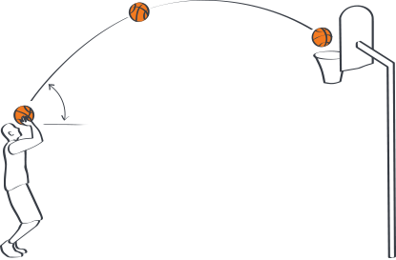  As you see, in basketball we use parabola , the graph of quadratic equation.  Video from youtube:  https://youtu.be/kUpzf16uhG0  In this moment, students will understand the meaning and importance of topic.  A quadratic equation is an equation that can be written in the form ax2 + bx + c = 0, where a, b and c are real numbers and a ≠ 0.  For example,  x2 + 3x = 10, x2 – 4x + 2 = 0 and x2 = 9 are quadratic equations. 6x = 12 and x = –2 are  not quadratic equations because a = 0.  Sometimes a quadratic equation is called a second degree equation, because the degree of the polynomial ax2 + bx + c is 2.  When a quadratic equation is written as ax2 + bx + c = 0, we say it is in standard form.  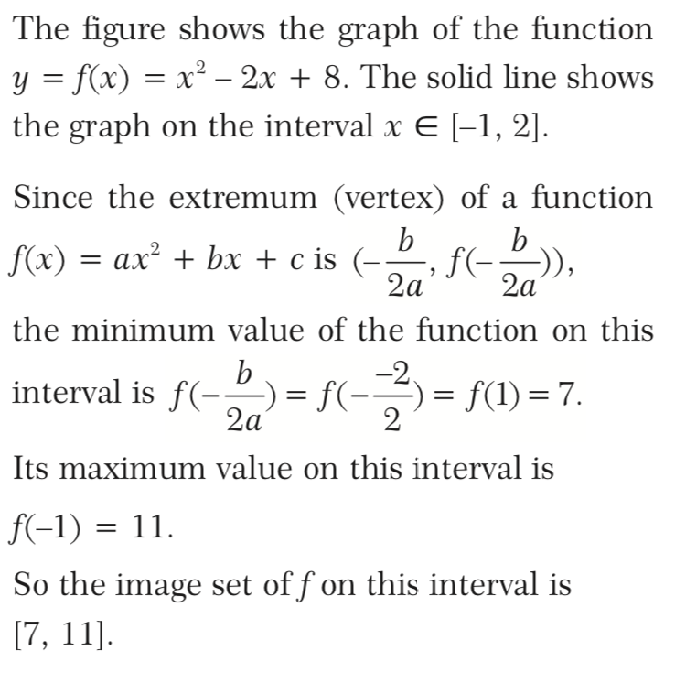  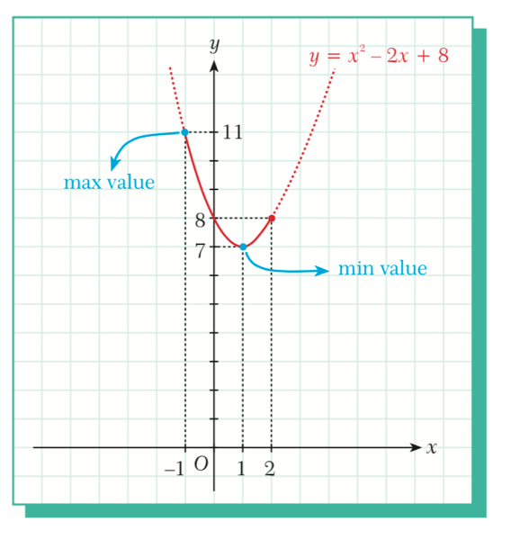  All students should open the “geogebra” site from their gadgets and make a practice.  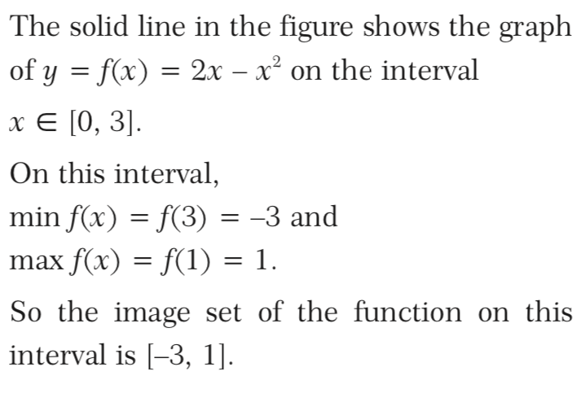  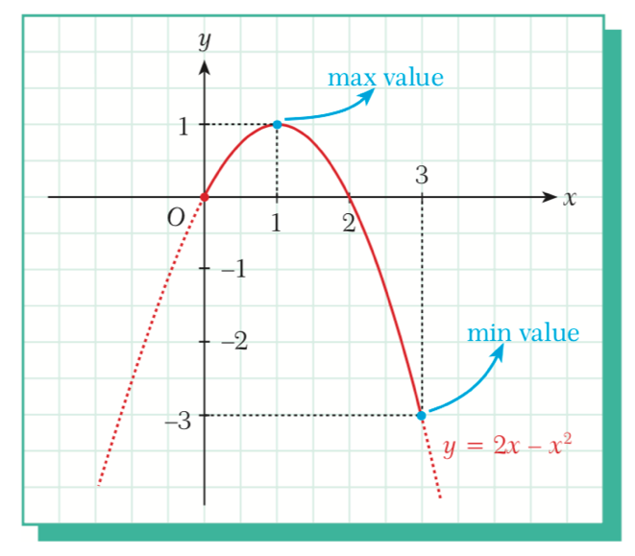  Get feedback. Ask students do they understand or do they have any questions?  If everything is clear, it’s time for project task.  . Instruction:  - Class should be divided into 3 groups by their math levels  - They measure levels by themselves (I good in math, not good/not bad, I’m not good in math)  - Teacher will give task: Measure any parabola figure from the real life.  - Student able to use any gadgets they want.  Analyse and give/get feedback. |  |  | Website  Google.com  Website  Youtube.com  9th grade algebra  Astana kitap  9th grade algebra  Astana kitap  9th grade algebra  Astana kitap

Additional information
Differentiation - how do you plan to provide more support? What tasks do you plan to set for more capable students? | Assessment - how do you plan to check the level of students studying ? |  | Health and safety
The lesson is planned in such a way that less confident students work in pair, where they can learn in dialogue and look at the approaches of more confident students. | Formative assessment by observing the participation of students in the work and discussion.  Progress and feedback from paired activities will be carefully followed to measure individual contributions and identify any misunderstandings. |  | Estimates:  Students will need to be creative, think about new situations.  By participating in paired work, they will be able to appreciate the need to be responsible students, listen to their work partner, exchange ideas, and participate in discussion.
Reflection  Were the lesson goals/learning goals real? What have students learned for today 's lesson? What was the atmosphere in the lesson? Was my differentiation good? Did I keep up in time? What changes have I made to my plan and why? |  | Use this section for reflection. Answer questions about your lesson from the left column.
Overall assessment
Which two aspects of the lesson were good (think about both teaching and learning)?
1:
2:
Which two things could improve the lesson (think about both teaching and learning)?
1:
2:
What have I learned during class or individual students that will help me prepare for the next lesson?

